CAREL CONTROLLER MODBUS RTU TECHNICAL INFORMATION

# OVERVIEW

This document contains the details information of the Carel controller interface description and Modus registers of the parameters that implement to the algorithm in the controller. Carel controller is a parametric controller with complete management of the operation of air conditioner. All parameter settings are pre-programmed at the factory, and the cooling/heating setpoints are designed to be configurable with the design ranges. The cooling/heating setpoint, cooling/heating differential setpoint, and some alarms setpoint can be accessible J4 or RS-485 interface on controller utilizing Modbus RTU. Most of the alarms are output through the alarm relay terminal which allows to connect to customer’s alarm device externally.

# CONTROLLER INTERFACES INFORMATION

This section illustrates the display and interface connectors information of the controller.

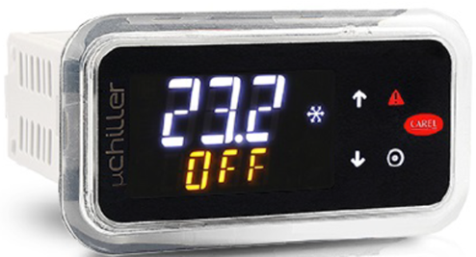 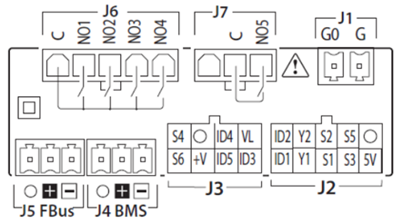

Figure to the right illustrates the interface connectors on the back of the controller. The RS-485 or J4 interface is designed to accessible to the parameters in the controller where it also allows to adjust the parameter setting within the design range. The communication of J4 support Modbus RTU and is pure RS485 serial level protocol that distinguish from Modbus TCP/IP.

## RS-485 serial communication, J4 Configuration

Here are the configuration of RS-458 or J4

|  |  |
| --- | --- |
| **Description** | **Setting** |
| Baud rate | 57600 |
| Bits | 8 |
| Parity | None |
| Stop bit | One |
| Device address | 4 |
| Security | None |

## J4 BMS Mating Connector

Table below obtains the J4 mating connector information and this connector is available in Digi-Key and Mouser. See information in below table for details.

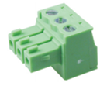 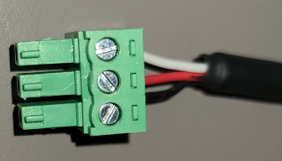

|  |  |  |  |  |
| --- | --- | --- | --- | --- |
| **Description** | **Manufacturer** | **MFG Part Number** | **Digi-Key P/N** | **Mouser P/N** |
| Conn, 3POS Plug 0.138” (3.50mm) pitch | DEGSON | 15EDGK-3.81-03P-14-00AH | - | - |
| **Alt.** | Phoenix Contact | 1840379 | 277-2413-ND | 651-1840379 |

# MODBUS RTU INFORMATION

The parameter settings in the controller are designed to be configurable and can be accessible through RS-485, J4 interface utilizing Modbus RTU. Table below obtains the mnemonic of the parameter, the factory default setting, design range, and Modbus register that provides to end-user to implement to their software to request the information from the controller.

Table 1: Parameters and its Modbus registers

|  |  |  |  |  |  |  |  |  |  |  |
| --- | --- | --- | --- | --- | --- | --- | --- | --- | --- | --- |
| **Para** | **Description** | | **Default** | **Min** | **Max** | **UOM** | **Level** | **RW** | **Modbus Reg** | **Variable** |
| **Temperature and Relative Humidity Setting Parameters (r*)** | | | | | | | | | | |
| r01 | | Cooling temperature setpoint | 80 | r02 | r03 | °F | U | RW | 51 | Analog |
| r04 | | Cooling temperature differential 1 setpoint | 7 | r05 | r06 | °F | U | RW | 54 | Analog |
| r10 | | High temperature setpoint | 125 | r11 | r12 | ᵒF | U | RW | 60 | Analog |
| r13 | | Low temperature setpoint | 40 | r14 | r15 | ᵒF | U | RW | 63 | Analog |
| r18 | | Heating setpoint | 50 | r19 | r20 | ᵒF | U | RW | 68 | Analog |
| r21 | | Heating temperature differential setpoint | 7 | r22 | r23 | ᵒF | U | RW | 71 | Analog |
| **Control Setting Parameters (c*)** | | | | | | | | | | |
| c12 | | Evaporator fan start-up delay time before compressor starts | 0 | 0 | 999 | sec | U | RW | 43 | Integer |
| c13 | | Evaporator fan stop delay time after compressor stops | 0 | 0 | 15 | min | U | RW | 44 | Integer |
| C19 | | Hysteresis operating scheme  0 = positive hysteresis  1 = negative hysteresis | 0 | 0 | 1 | Flag | U | RW | 19 | Digital |
| C21 | | Alarm relay output (N05)  0 = normally open (NO)  1 = normally close (NC) | 0 | 0 | 1 | Flag | U | RW | 21 | Digital |
| **Unit Setting Parameters (H*)** | | | | | | | | | | |
| H05 | | Door open switch controlling  0 = normally open (NO)  1 = normally close (NC) | 1 | 0 | 1 | Flag | U | RW | 22 | Digital |
| H13 | | Temperature scale selection  0 = degree Celsius (ᵒC)  1 = degree Fahrenheit (ᵒF) | 1 | 0 | 1 | Flag | U | RW | 26 | Digital |
| H16 | | Alarm history reset  0 = no change  1 = reset all alarms | 0 | 0 | 1 | Flag | U | RW | 27 | Digital |
| H17 | | Factory default reset  0 = no change  1 = reset all parameters | 0 | 0 | 1 | Flag | U | RW | 28 | Digital |

# INSTALLATION PROCEDURES

Figure below illustrates the block diagram that wires from the controller to the external electronic device, for example, PLC or industrial network protocol converter.

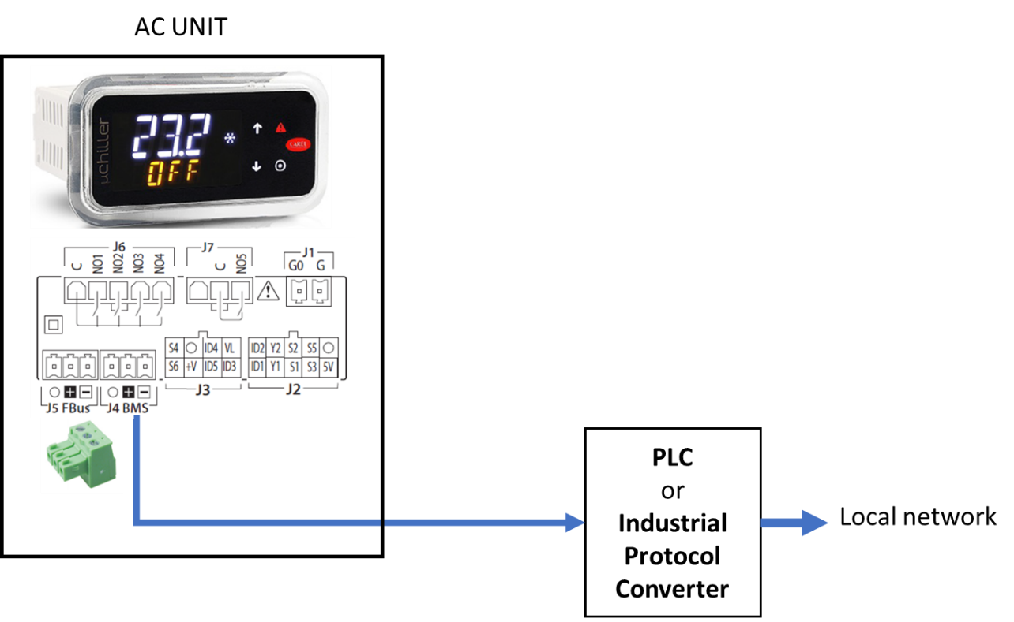

Figure 1: Illustrates block diagram of AC unit to PLC to local network

1. Connect the datable or communication cable from J4 on the back of the controller as illustrated in the above figure to the PLC or an industrial protocol converter
2. For remote access capability, the Modbus registers of the parameters that provide in Table 1 must incorporate to the custom software as needed
3. The PLC or the industrial protocol converter device communicates to the controller directly utilizing Modbus RTU or RS485 serial protocol
4. Note that each parameter obtaining in Table 1 is designed to be configurable within the design range